

**Extra Credit – Confirm Working Monitor Mode Adapter on Kali**

**Instructor: Prof. David Vargas**

**Introduction:** Early in the course students were encouraged to start their search for a wireless adapter that supports monitor mode and functions properly on one’s Kali Linux operating system (created from .ISO source file). This week students are scheduled to officially complete the following two related labs:

* Add External Wireless Adapter to a VirtualBox VM
* Test WLAN Adapters for Monitor Mode and Packet Injection on Linux

After completing these labs, students will have a WLAN adapter that is properly configured to complete future textbook assignments.

Students will receive ***5 points*** extra credit, if they can prove that their WLAN adapter functions properly in monitor mode by using Wireshark to capture WLAN traffic subtypes. The following is an excellent example that was provided by a previous student:

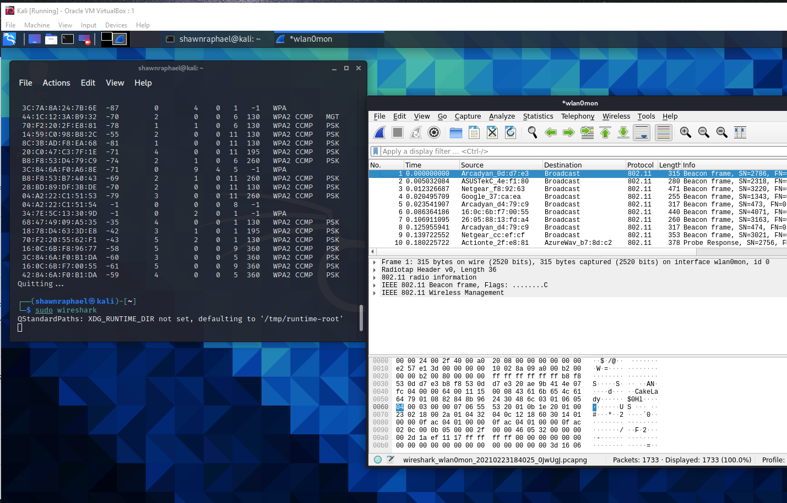

In the above screenshot, the instructor could see the student’s name at the command prompt (i.e., ShawnRaphael) and beside it there is a Wireshark capture that proves the adapter is in monitor mode (i.e., it displays the capture of Wi-Fi beacons). Students are to provide a similar example where applicable on the answer sheet.

**Submission Instructions:**

* Email the *answer sheet (ONLY) in Word format* to [david.vargas@montgomerycollege.edu](mailto:david.vargas@montgomerycollege.edu) before the last class meeting on **August 12, 2025** 
  + Late Submissions will NOT be accepted.
  + Resubmissions will NOT be accepted (the first submission is the only submission that will be accepted).
* Question #2 will NOT be graded if Question #1 is not answered correctly.
* Points will be deducted for not following instructions.

**Note:** The Cyber Lab has wireless adapters that students can borrow and use in the Cyber Lab to complete this extra credit.

**ANSWER SHEET**

**Students are to enter their answers/screenshots below and return this page *ONLY.***

**Student’s Name:**

**WLAN Adapter Vendor:**

**WLAN Adapter Model:**

1. **Provide a READABLE screenshot that shows the Kali Linux commands one would enter at the Kali CLI to manually enable monitor mode. Be reminded that Question #2 will not be graded if this question is answered incorrectly. *(Note: Simply launching a wireless security application that enables monitor mode will not satisfy this requirement)* [2.5 points]:**
2. **Provide a READABLE screenshot EXACTLY like the example on the first page that displays one’s name in the Kali Linux command prompt (left side) and a Wireshark packet capture that displays monitor mode Wi-Fi traffic (right side). [2.5 points]:**

**GRADING (FOR INSTRUCTOR USE ONLY):**